Software Requirements Specification

for

Student Help Desk Technician

Version 1.0 approved

Prepared by Md. Abu Hanif

North East Universty Bangladesh

19-01-2020

Table of Contents

Table of Contents ii

Revision History ii

1. Introduction test 1

1.1 Purpose 1

1.2 Document Conventions 1

1.3 Intended Audience and Reading Suggestions 1

1.4 Product Scope 1

1.5 References 1

2. Overall Description 2

2.1 Product Perspective 2

2.2 Product Functions 2

2.3 User Classes and Characteristics 2

2.4 Operating Environment 2

2.5 Design and Implementation Constraints 2

2.6 User Documentation 2

2.7 Assumptions and Dependencies 3

3. External Interface Requirements 3

3.1 User Interfaces 3

3.2 Hardware Interfaces 3

3.3 Software Interfaces 3

3.4 Communications Interfaces 3

4. System Features 4

4.1 System Feature 1 4

4.2 System Feature 2 (and so on) 4

5. Other Nonfunctional Requirements 4

5.1 Performance Requirements 4

5.2 Safety Requirements 5

5.3 Security Requirements 5

5.4 Software Quality Attributes 5

5.5 Business Rules 5

6. Other Requirements 5

Appendix A: Glossary 5

Appendix B: Analysis Models 5

Appendix C: To Be Determined List 6

Revision History

|  |  |  |  |
| --- | --- | --- | --- |
| **Name** | **Date** | **Reason For Changes** | **Version** |
|  |  |  |  |
|  |  |  |  |

# Introduction

## Purpose

The SRS typically contains the brief description of the project.The purpose of this source is to describe the Student Help Desk Technician which provides the all the information about an university students results , routines, CGPA calculator ,offered courses ,overlapping courses etc .The main purpose of this project is to maintain easy circulation system using computers and provide different reports.

An SRS provides a reference for validation of the final product. A high quality SRS is a prerequisite to high quality software and it also reduces the development cost

## Document Conventions

* Entire document should be justified.
* Convention for main title:

1) Font Face: Times New Roman.

2) Font Style: Bold.

3) Font Size: 32.

* Convention for sub title:

1) Font Face: Times New Roman.

2) Font Style: Bold.

3) Font Size: 32.

* Convention for body:

1) Font Face: Times New Roman.

2) Font Style: Normal.

3) Font Size: 11.

## Intended Audience and Reading Suggestions

* Students
* Authority
* Developers
* Users

## Product Scope

Student Help Desk Technician is an attempt to simulate the basic concepts of an online function for the students to get all the necessary information regarding their offered courses, routines and results. The document only covers the requirements specifications for the Student Help Desk Technician. This document does not provide any references to the other component of the Student Help Desk Technician. All the external interfaces and the dependencies are also identified in this document. It is basically a website for all the students who are interested to know their academic activities alltogether . This project is specifically designed for the use of students and authority. The project will work as a complete user interface and usage from ordinary users. This project can be easily implemented under various situations. We can add new features as and when we require, making reusability possible as there is flexibility in all the modules. The language used for developing the project is PHP, Java Script, HTML5, CSS all of these are quite advantageous than other languages in terms of performance, tools available, cross platform compatibility, libraries, cost (freely available & open source), and development process.

## References

* PHP: - <http://www.phptherightway.com/>
* HTML5: - <http://www.w3schools.com/>
* CSS3: - <http://www.w3schools.com/>
* JAVA Script: - <http://www.w3schools.com/>

# Overall Description

## Product Perspective

There are some drawbacks of manual systems. Students often feels trouble to find their semester routine,offered courses,results etc. The main purpose of this project to resolve these difficulties for the students. A computerized system will provide easy access to get all the informations about their academic help.

## Product Functions

* The main purpose of this project is to reduce the manual work.
* This software is capable of showing results with ranking
* Students can create a routine which will show if there are any overlapping course routine(in needed)
* Can comment about anything needed.
* Show important updates and notices.
* Can calculates overall cgpa.
* It will provide their course routines .

## User Classes and Characteristics

We have two levels of users-

* Users: Mainly students are considered as the end users.
* Admin: An admin can edit,update,delete in the system.

## Operating Environment

The product will be operating in windows environment. The Student Help Desk Technician is a website and shall operate in all famous browsers, for a model we are talking Microsoft Internet Explorer, Google Chrome and Mozilla Firefox. Also it will be compatible with the IE 6.0. Most of the features will be compatible with the Mozilla Firefox and Opera 7.0 or higher version. The only requirement to use this online product would be the internet connection.

The hardware configuration include Hard Disk: 40GB, Monitor: 15 inch Color monitor, Keyboard: 122 keys. The basic input devices required are keyboard, mouse and output devices are monitor etc.

## Design and Implementation Constraints

All users need an unique userId and password to access the system. For any new user they must need to signup first.Students must give their university registration number.

## User Documentation

The product will include user manual. The user manual will include product overview, complete configuration of the used software (such as SQL server), technical details, backup procedure and contact information which will include email address. There will be no online help for the product at this moment. The product will be compatible with the Internet Explorer 6.0 or higher. The databases will be created in the MySQL.

## Assumptions and Dependencies

The assumptions are:-

* The coding should be error free.
* The system should be user friendly so that it is easy to use for the users.
* The information of all users and other things must be stored in a database that is accessible by the website.
* The system should have more capacity and provide fast access to the databse.
* The system should provide search facility and support quick transactions.
* Users may access from any computer that has internet browsing capabilities and an internet connection.
* Users and authority must have their correct username and passwords to enter into their online accounts and do actions.

The dependencies are :-

* The specific hardware and software due to which the product will be run.
* On the basis of listing requirements and specification the project will be develop and run.
* The end users should have proper understanding to the product.
* The system should have the general report store.
* The information of all users must be stored in a database that is accessible by the system.
* Any update regarding the results,routines ,notices is to be recorded to the database and the data entered should be correct.

# External Interface Requirements

## User Interfaces

The software provides good graphical interface for the user and admin can operate on the system.

* User can see on result, syllabus, and routine from the user panel.
* User can view the offered course & registry details.
* Admin can View, Edit and Delete everything.

➔ Home of user panel:

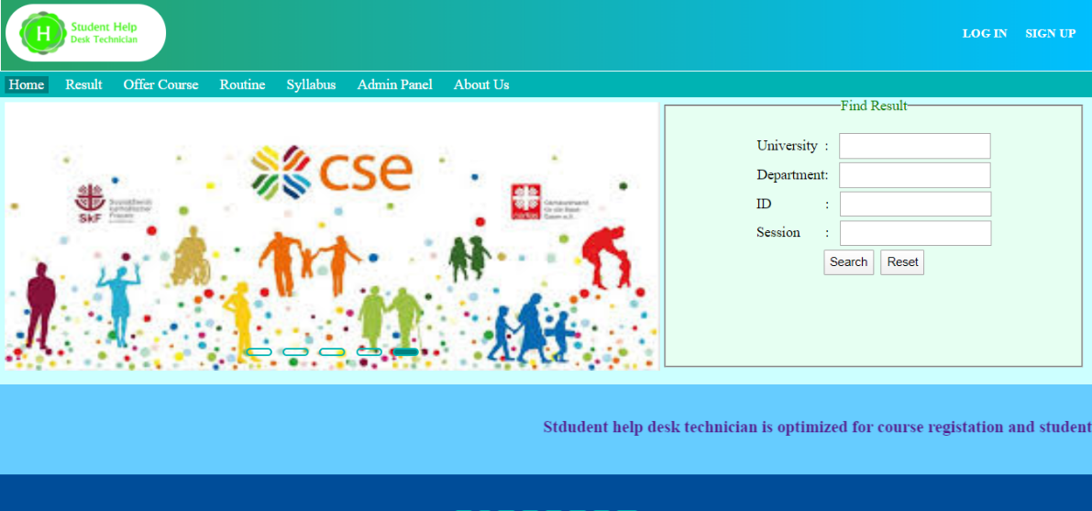

➔ Result Search box and result rank page in user panel:

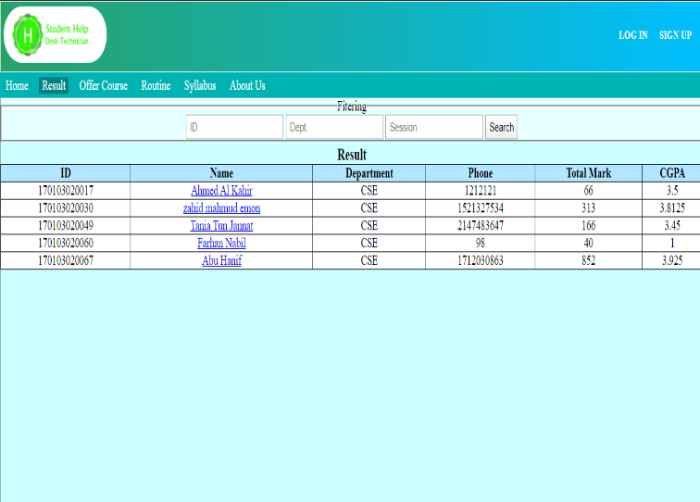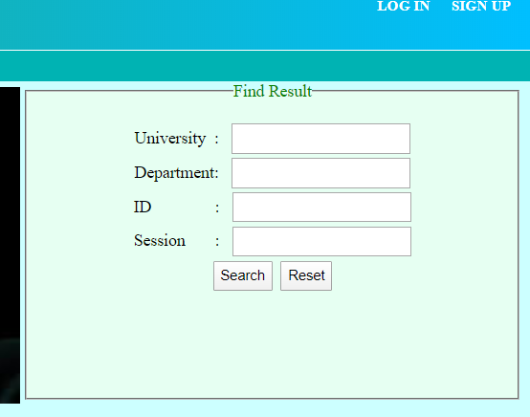

➔ Offered Course page in user panel:

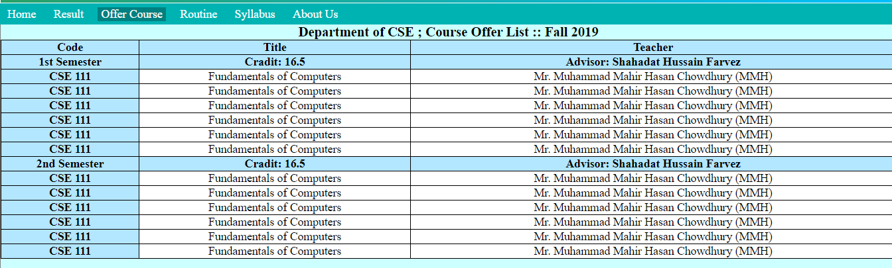

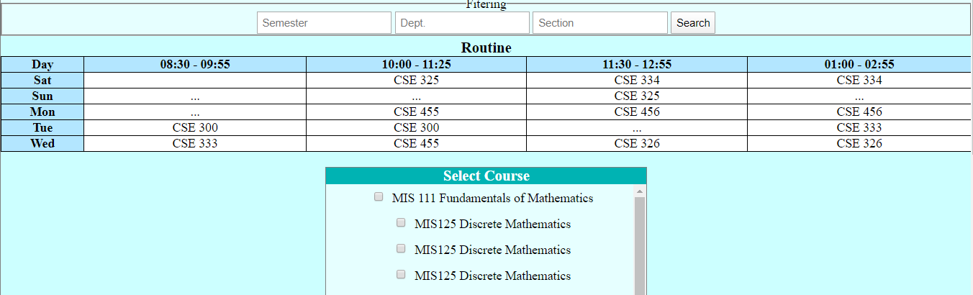➔ Offered Course page in user panel:

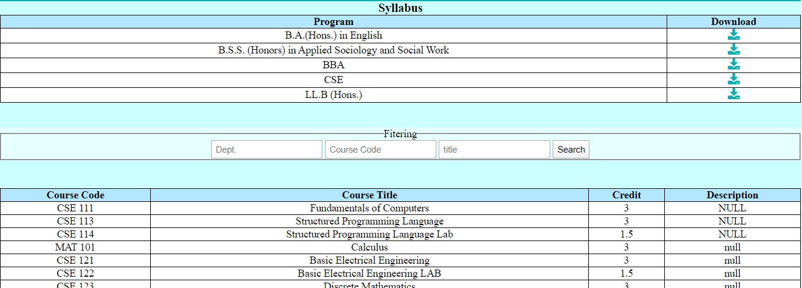➔ Syllabus page in user panel:

➔ About page in user panel:

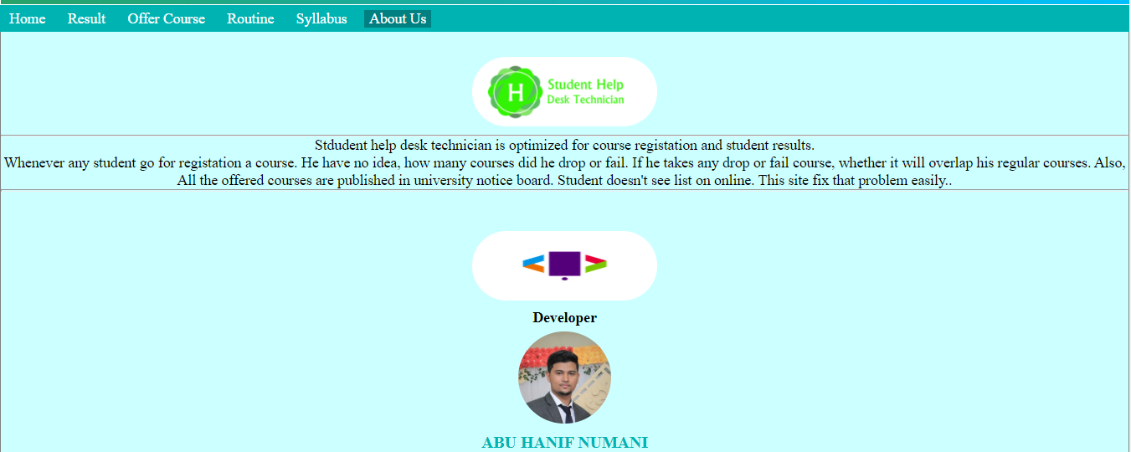

➔ Sign In and Sign-out page in user panel:

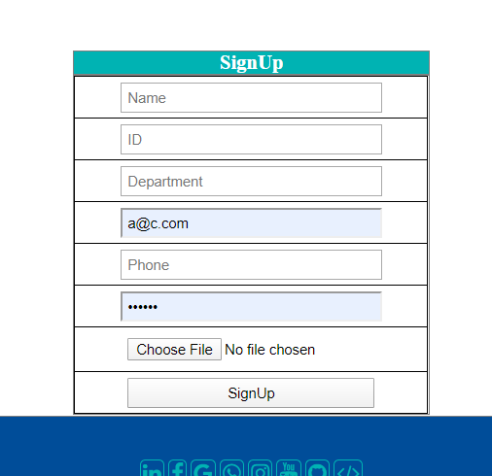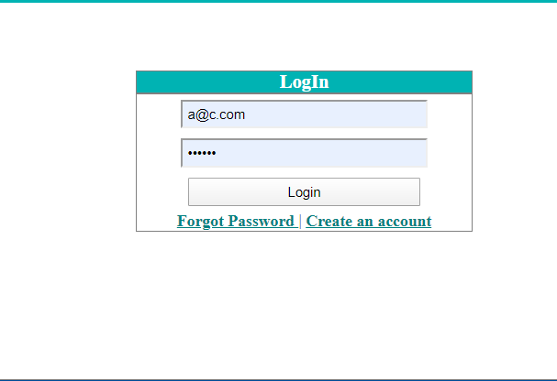

## Hardware Interfaces

* Operating system : windows
* Hard disk :40 GB
* RAM: 512 MB.
* Processor : Pentium(R)Dual-core CPU

## Software Interfaces

* XAMPP
* NOTEPAD++
* MySQL

## Communications Interfaces

The Customer must connect to the Internet to access the Website:

* Dialup Modem of 52 kbps
* Broadband Internet
* Dialup or Broadband Connection with a Internet Provider.

# System Features

## System Feature :

The users of the system should be provided the surely that their account is secure this is possibly by providing:

* User authentication and validation of members using their unique member ID.
* Proper maintaining by administrator.
* The system will faster to the user.
* All the informations for students are accurate.
* Their ranking position will update every semester.
* Search option based on students Id.
* Pages will update dynamically by the authority.

# Other Nonfunctional Requirements

## Performance Requirements

The capability of the computer depends on the performance of the software. The software can take any number of inputs provided the database size is larger enough. This would depend on the available memory space.

The proposed system that we are going to develop will be as the chief performance system within all online reservation system. Therefore it is expected that database would perform functionally at the requirements that are specified by the authority.

* The performance of the system should be fast and accurate.
* Student Help Desk Technician shall handle expected and non expected errors in ways that prevent loss in information and long downtime period. Thus it should have in built error testing to identify invalid username or password.
* The system should be able to handle large amount of data. Thus it should accommodate high number of books and users without any fault.

## Safety Requirements

The database may get crushed at any certain time due to virus or operating system failure. There for it is required to take the database backup so that the database is not lost. Proper UPS/ Inverter facility should be there in case of power supply failure.

## Security Requirements

* System will use secured database.
* Normal users can just read information but they cannot edit or modify anything.
* System will have different types of user and every user has access constraints.
* Proper user authentication should be provided.
* No one should be able to hack user password.
* There should be separate accounts for admin and users. Only admin has the rights to access the database and update it.

## Software Quality Attributes

* There may be multiple admin’s creating the project, all of them will have the right to create changes to the system. But the members or other users cannot do changes.
* The project should be open source.
* The quality of the database is maintained in such a way so that it can be very user friendly to all the users of the database.
* The user be able to easily download and install the system.

## Business Rules

A business rule is anything that captures and implements business policies and practices. A rule can enforce business policy, make a decision, or infer new data from existing data. This includes the rules and regulations that the system users should abide by. This includes the cost of the project and the discount offers provided. The users should avoid illegal rules and protocols. Neither admin nor members should cross the rules and regulations.

# Other Requirements

There are different categories of users namely User, Registered User, Admin. Depending upon the category of user the access rights are decided. It means if the user is an administrator then he can be able to modify the data, delete, append etc. All other users except the admin only have the rights to retrieve the information about database.

Appendix A: Glossary

The following are the list of conventions and acronyms used in this document and the project as well:

* Administrator: A log in id representing a user administration privileges to the software.
* User: Normally user can
* Client: Intended users for the software.
* SQL: Structured Query Language,used to retrieve information from databse.
* Layer: Represents a section of the project.
* User interface layer: The section of the assignment reffering to what the user interacts with directlt.
* Application logic layer: The section of the assignment reffering to the web server. Thios is where all computations are completed.
* Data storage level: The section of assignment reffering to where all data is recorded.
* Use case: A broad level diagram of the project showing a basic overview.
* Class diagram:It is a type of diagram that describes that the structures of a system by showing the system’s cases,their attributes ,and the relationships between the classes.
* Interface: Something used to communicate accorss different mediums.
* Unique key: Used to differentiate entries in a database.

Appendix B: Analysis Models

1. All Table:

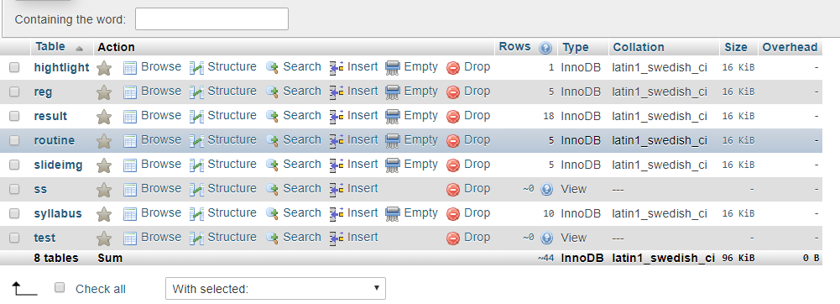

1. Routine:

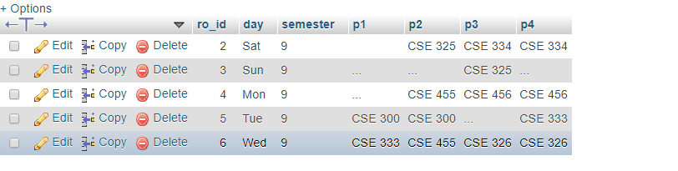

1. Result:

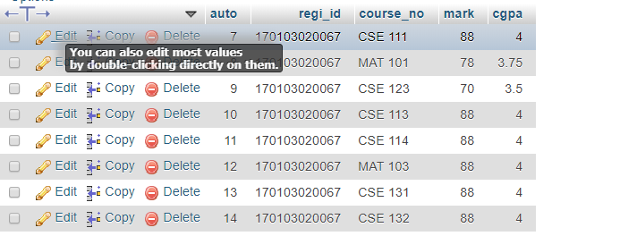

1. Reg: